# Mathematical Methods in Engineering and Applied Science. Problem Set 9.

1. For the equation $\ddot{x} + μ(x^{2}+ {\dot{x}}^{2}-1) \dot{x} + x = 0$, where $μ > 0$:
2. Find and classify all the fixed points.

Let $\dot{x}=y=>\ddot{x}=\dot{y}$

$$\ddot{x} + μ\left(x^{2}+ {\dot{x}}^{2}-1\right) \dot{x} + x = \dot{y}+μ\left(x^{2}+ y^{2}-1\right) y + x=0$$

$$\dot{y}=-μ\left(x^{2}+ y^{2}-1\right) y- x$$

We have got system:

$$\dot{x}=y$$

$$\dot{y}=-μ\left(x^{2}+ y^{2}-1\right) y- x$$

$$J=\left[\begin{matrix}0 & 1 \\ -1-2yμx & μ-2μx\end{matrix}\right]$$

Fixed points:

$$y=0=>x=0$$

$$J=\left[\begin{matrix}0 & 1 \\ -1 & μ\end{matrix}\right]$$

$$τ=μ, ∆=1$$

$$τ^{2}-4∆=μ^{2}-4$$

|  |  |  |  |
| --- | --- | --- | --- |
| Fixed point | $$v_{1},v_{2}$$ | $$λ_{1},λ_{2}$$ | Type |
| (0,0) | … | $$\frac{1}{2}\left(μ+\sqrt{μ^{2}-4}\right), \\ \frac{1}{2}\left(μ-\sqrt{μ^{2}-4}\right)$$ | If $0<μ<2=>$ unstable spiral.  If $μ>2=>$ unstable node.  If $μ=2=>$ unstable degenerate node |

1. Show that the system has a circular limit cycle and find its amplitude and period.

Represent (a) as $\ddot{x} + x = μ(x^{2}+ {\dot{x}}^{2}-1) \dot{x}$

Right hand side is external forces. We can find possible circular limit cycle from $\frac{dE}{dt}=0$.

$$E = T+V=\frac{{\dot{x}}^{2}}{2}+\frac{x^{2}}{2}=\frac{1}{2}\left({\dot{x}}^{2}+x^{2}\right)$$

$$\frac{dE}{dt}=\frac{d}{dt}\left(\frac{1}{2}\left({\dot{x}}^{2}+x^{2}\right)\right)=\frac{1}{2}\left(2\dot{x}\ddot{x} +2x \dot{x}\right)=\dot{x}\ddot{x}+x\dot{x}=\dot{x}\left( \ddot{x}+x\right) \\ =\dot{x}\left(μ\left(x^{2}+ {\dot{x}}^{2}-1\right) \dot{x}\right)=y^{2}μ\left(x^{2}+ y^{2}-1\right)=0$$

$$x^{2}+y^{2}=1$$

Check it in polar coord system:

$$\dot{x}=y$$

$$\dot{y}=-μ\left(x^{2}+ y^{2}-1\right) y- x$$

$$x=rcos\left(ϕ\right), y=r\sin\left(ϕ\right)$$

$$\dot{r}\cos\left(ϕ\right)-rsin\left(ϕ\right)\dot{ϕ}=r\sin\left(ϕ\right)$$

$$\dot{r}\sin\left(ϕ\right)+rcos\left(ϕ\right)\dot{ϕ}=-μ\left(r^{2}-1\right) r\sin\left(ϕ\right)- rcos\left(ϕ\right)$$

We suppose $$r^{2}=x^{2}+y^{2}=1=>r=1$$

$$\dot{r}\cos\left(ϕ\right)-sin\left(ϕ\right)\dot{ϕ}=\sin\left(ϕ\right)$$

$$\dot{r}\sin\left(ϕ\right)+cos\left(ϕ\right)\dot{ϕ}=- cos\left(ϕ\right)$$

$$\dot{r}ctg\left(ϕ\right)-\dot{ϕ}=1$$

$$\dot{r}tg\left(ϕ\right)+\dot{ϕ}=-1$$

Summing both:

$$\dot{r(}tg\left(ϕ\right)+ctg\left(ϕ\right)) =0$$ $ϕ$ is arbitrary=> $\dot{r}=0$ 
Finding $ϕ$

$$\dot{r}-tg\left(ϕ\right)\dot{ϕ}=tg\left(ϕ\right)$$

$$\dot{r}+ctg\left(ϕ\right)\dot{ϕ}=- ctg\left(ϕ\right)$$

Subtracting both:

$$-tg\left(ϕ\right)\dot{ϕ}-ctg\left(ϕ\right)\dot{ϕ}=tg\left(ϕ\right)+ ctg\left(ϕ\right)$$

$ϕ$ is arbitrary=>

$$\dot{ϕ}=-1, ϕ=-t=>period 2π$$

Conclusion:

circular limit cycle exist at $x^{2}+y^{2}=1$, amplitude is unit, period is $T=2π$

1. (Extra credit ). Determine the stability of the limit cycle. Give an argument which

shows that the limit cycle is unique, i.e., there are no other periodic trajectories.

From polar coordinate system:

If $r<1=>\dot{r}>0$

If $r>1=>\dot{r}<0$  
It means that limit cycle is stable, because system converge to this cycle.

$\frac{dE}{dt}=0$ only in cycle $x^{2}+y^{2}=1$,and $y = 0$,otherwise energy isn’t conserved.

$x^{2}+y^{2}=1$ is limit cycle, y = 0 is not closed curve, it is the point. So, the limit cycle is unique: $x^{2}+y^{2}=1$.

1. Investigate the phase plane of the system $\dot{x} = y, \dot{y} = x(μ -x^{2})$, for μ < 0, μ = 0, and

μ > 0. Describe the bifurcation as μ increases through zero.

$$\dot{x} = y, \\ \dot{y} = x\left(μ -x^{2}\right)$$

$Fixed points:$ $\left(0,0\right);$ if μ>0 then additional point: $(±\sqrt{μ},0)$

$$J=\left[\begin{matrix}0 & 1 \\ μ-3x^{2} & 0\end{matrix}\right]$$

$J\left(0,0\right)=\left[\begin{matrix}0 & 1 \\ μ & 0\end{matrix}\right]=>τ=0,∆=-μ,$ if $μ≤0$ => center, $μ>0$ saddle point, $J\left(±\sqrt{μ},0\right)=\left[\begin{matrix}0 & 1 \\ -2μ & 0\end{matrix}\right]=>τ=0,∆=2μ, μ>0=>$  
 center.

When $μ$ goes from $-∞$ to 0 there is one stable point. When $μ$ goes from $0$ to $∞$ there is 2 stable point and 1 unstable. Bifurcation is a supercritical pitchfork.

$$μ=-1:$$

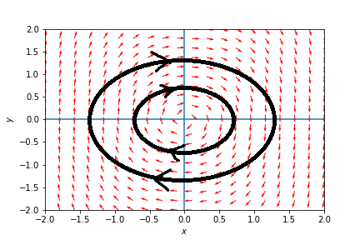

$μ=0$:

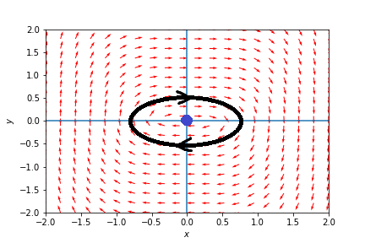

$μ=1$:

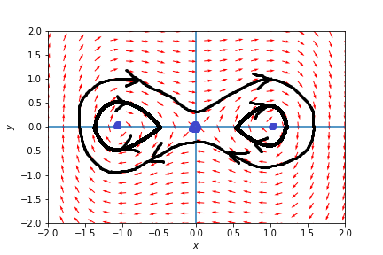

1. Consider the equation $\ddot{x} + μf \left(x\right) \dot{x} + x = 0$, where $f = -1$ for $|x| < 1$ and $f = 1$ for $|x|≥1$.
2. Show the system is equivalent to $\dot{x} = μ\left(y -F \left(x\right)\right), \dot{y} = -\frac{x}{μ}$ where
$$F =\begin{matrix}x + 2, x ≤-1 \\ -x, |x|< 1 \\ x -2, x ≥1.\end{matrix}$$

$$\ddot{x} = μ\left(\dot{y} -\frac{dF}{dt} \left(x\right)\right)=-x-μ\left[\begin{matrix}\dot{x}, x ≤-1 \\ -\dot{x}, \left|x\right|< 1 \\ \dot{x}, x ≥1\end{matrix}\right]=-x-μ \dot{x}\left[\begin{matrix}1, x ≤-1 \\ -1, \left|x\right|< 1 \\ 1, x ≥1\end{matrix}\right]= \\ -x-μ \dot{x}\left[\begin{matrix}1, \left|x\right|≤-1 \\ -1, \left|x\right|< 1\end{matrix}\right]=-x-μ \dot{x}f\left(x\right)=0$$

$$=>\ddot{x}+x+μ \dot{x}f\left(x\right)=0$$

3. Graph the nullclines.

To $$\dot{x} = μ\left(y -F \left(x\right)\right), \\ \dot{y} = -\frac{x}{μ}$$

Nullclines:

$$y= F \left(x\right), \\ x is any$$

$$x=0$$

$$y is any$$

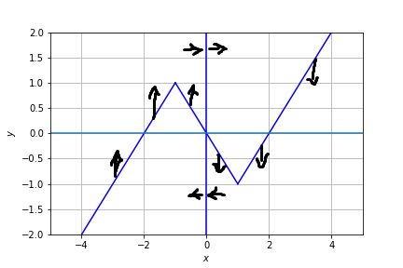

1. Show that the system exhibits relaxation oscillations for μ ≥ 1, and plot the limit

cycle in the (x,y) plane.

Let the point at “A”, $y=F(x)$, then $\dot{y} = -\frac{x}{μ}≪1$, $\dot{x}$ is small and move point back to line F(x).So, it slowly climbs on the pick of trajectory “B”, after that $\dot{y} = -\frac{x}{μ}≪1$, but $\dot{x} = μ\left(y -F \left(x\right)\right)≫1$, because $μ>1; \frac{1}{μ}<1$.

So point will fast run in x direction, after that it will on “C” - F(x) line and again slowly clime on pick.

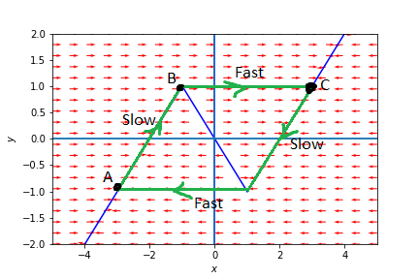

1. (Extra credit ). Estimate the period of the limit cycle for $μ >>1$.

If $μ >>1$ we can assume that time of traveling between B and C is small, because $\dot{x}$ is large.

$$T≈2\int_{C}^{D}{dt}$$

$$\dot{y}=-\frac{x}{μ} \\ \frac{dy}{dt}=-\frac{x}{μ}$$

From geometry $y=F\left(x\right)=x+2=>dy=dx$

$$\frac{dx}{dt}=-\frac{x}{μ}$$

$$dt=-\frac{μ}{x}dx$$

$$T≈2\int_{C}^{D}{dt}=2\int_{X_{C}}^{X_{D}}{-\frac{μ}{x}dx}=-2μ\left(\ln\left(x_{D}\right)-\ln\left(x_{C}\right)\right)=-2μ\left(\ln\left(1\right)-\ln\left(3\right)\right)=2μln⁡(3)$$

1. Consider the system
$$\dot{x} = -y + μx + xy^{2}, \dot{y} = x + μy -x^{2}.$$

2. Linearize about the origin and determine the type of the fixed point.

Fixed points (0,0)

$$J\left(0,0\right)=\left[\begin{matrix}μ & -1 \\ 1 & μ\end{matrix}\right];τ=μ+μ=2μ;∆=μ^{2}+1$$

$$τ^{2}-4∆=4μ^{2}-4\left(μ^{2}+1\right)=-4$$

If $μ<0$ => stable spiral

If $μ>0$ => unstable spiral

1. Write down the system to find all the fixed points. Eliminate y to find the equation

for $x_{c}(μ)$. Make a plot of this function to find out how many fixed points there are

for given μ.

$$\dot{x} = -y + μx + xy^{2}=0, \dot{y} = x + μy -x^{2}=0.$$

If $μ≠0$:

$$y=\frac{x^{2}-x }{μ}$$

$$\left(μ^{3}+{\left(x^{2}-x\right)}^{2}-μ\left(x-1\right)\right)x=0$$

If $μ=0$:

$$y\left(xy-1\right)=0$$

$$x\left(1-x\right)=0$$

If $μ=0$: We have Fixed points: (1,0)(1,1);

For all $μ$ We have Fixed points: (0,0);

Considering as a $x_{c}\left(μ\right)$ function:

$$\left(μ^{3}+{\left(x^{2}-x\right)}^{2}-μ\left(x-1\right)\right)x=0$$

$$\left(μ^{3}+{\left(x_{c}^{2}-x_{c}\right)}^{2}-μ\left(x_{c}-1\right)\right)x_{c}=0$$

Including (0,0) fixed point we obtain:

$μ<-0.14$: 3 fixed points

$μ=-0.14$: 4 fixed points

$-0.14<μ<0$: 5 fixed points

$μ=0$: 3 fixed points

$0<μ<0.21:$ 3 fixed points

$μ=0.21:$ 2 fixed points

$μ>0.21:$ 1 fixed point.

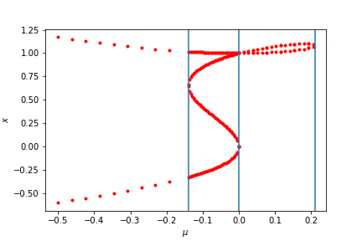

Supposed additional one fixed point (0,0)

1. Investigate numerically the nature of the solutions on a phase plane as µ varies about µ = 0.
2. What is the type of the bifurcation that takes place as µ crosses 0?

When $μ=-0.01$ there is stable spiral. With fixed point in (0,0) as we obtained in (a)

If $μ=0$ we have limit cycles. Finally at $μ=0.01$ we get unstable spiral. There is subcritical Hopf bifurcation (from(e)).

$$μ=-0.01$$

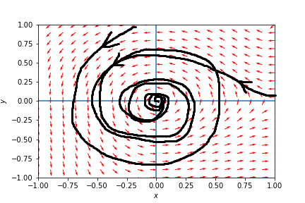

$$μ=0$$

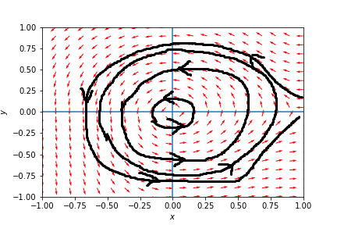

$$μ=0.01$$ 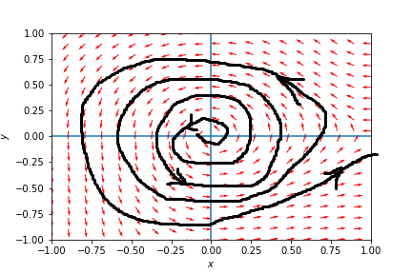

1. Rewrite the system in polar coordinates $x = rcos θ, y = rsin θ$ and approximate

the system assuming r small. Show that to leading order the system becomes

$$\dot{r} = μr +\frac{1}{8}r^{3}, \dot{θ} = 1,$$

and hence one can expect a limit cycle of radius $r ≈ \sqrt{-8μ}$ when μ < 0. Confirm

this numerically.

$$\dot{x}=\dot{r}\cos{θ}-rsin θ \dot{θ}= -rsin θ + μrcos θ + rcos θ{r^{2}sin θ}^{2}, \\ \dot{y}=\dot{r}sin θ+rcos θ \dot{θ} = rcos θ + μrsin θ -{r^{2}cos θ}^{2}.$$ After transformations:

$$\dot{r}=μr+r^{3}\cos^{2}{θ}\sin^{2}{θ}-r^{2}\cos^{2}{θ\sin{θ}} \\ \dot{θ}=1-r^{2}\cos{θ\sin^{3}{θ}}-r\cos^{3}{θ}$$

Since $r≪1=>\dot{θ}≈1$  
Since $\dot{r}$ is small as O(r) we can assume it is independent of $θ$, taking average of period.

$$\frac{1}{2π}\int_{0}^{2π}{\dot{r} dθ}=\frac{1}{2π}\int_{0}^{2π}{μr+r^{3}\cos^{2}{θ}\sin^{2}{θ}-r^{2}\cos^{2}{θ\sin{θ}} dθ}$$

Assume r is independent of $θ$

$$\dot{r}=\frac{1}{2π}\int_{0}^{2π}{\left(μr+r^{3}\cos^{2}{θ}\sin^{2}{θ}-r^{2}\cos^{2}{θ\sin{θ}}\right) dθ}=μr+\frac{1}{8}r^{3}$$

And we got before

$$\dot{θ}=1$$

$\dot{r}=0,$ when $r=\sqrt{-8μ}$

For $μ=-0.005$ $r=0.2$

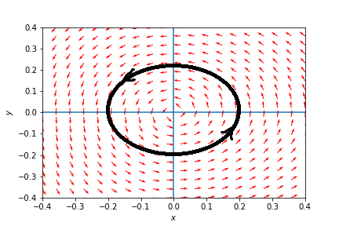

If $r<\sqrt{-8μ}$ => $\dot{r}<0$

If $r>\sqrt{-8μ}$ => $\dot{r}>0$ => it is unstable limit cycle.

For $μ<0$. unstable limit cycle means subcritical Hopf bifurcation.

1. (Extra credit). Consider the system
$$\dot{x} = y, \dot{y} = x^{2}-y -μ.$$

2. Analyze the fixed points of the system at all possible μ.

Fixed points: $y=0, x=±\sqrt{μ}=>if μ<0$ then there are no fixed points

$$J=\left[\begin{matrix}0 & 1 \\ 2x & -1\end{matrix}\right]$$

$J\left(\sqrt{μ},0\right)=\left[\begin{matrix}0 & 1 \\ 2\sqrt{μ} & -1\end{matrix}\right]=>τ=-1,∆=-2\sqrt{μ}<0=>$ saddle point ($\sqrt{μ},0)$

$$J\left(-\sqrt{μ},0\right)=\left[\begin{matrix}0 & 1 \\ -2\sqrt{μ} & -1\end{matrix}\right]=>τ=-1;∆=2\sqrt{μ}>0;τ^{2}-4∆=1-8\sqrt{μ}$$

If $\left(0<μ<\frac{1}{64}\right)=>τ^{2}-4∆>0=>$ stable node

If $\left(μ>\frac{1}{64}\right)=>$ stable spiral.

1. What type of bifurcation takes place as μ crosses 0?

For $μ<0$ there are no fixed points.

When $μ$ crossed 0 there are 2 fixed points: stable node and saddle point. => it is saddle-node bifurcation.

1. Draw the bifurcation diagram in the space of $x_{c}$ vs μ, where $x_{c}$ is the critical point.

$$x_{c}=±\sqrt{μ}$$

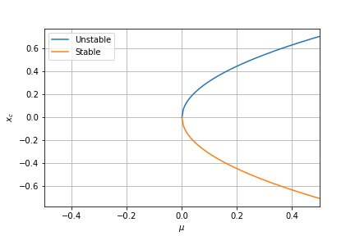

1. Plot the phase plane at μ = 0.01.

